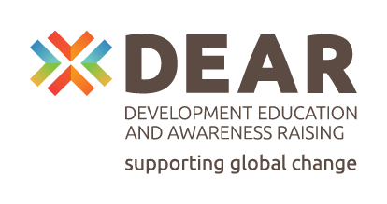
Turn the tables: Towards just, green and innovative food procurement!

Content reporting form

1. Data of the applicant:

Name:
Address:
Tax number
Name of the representative
- phone:
- e-mail:
Project manager name:
- phone:
- e-mail:

Project description

Activity name according to the application
Project name
Project length
Please explain how you implemented the project. Please mention other collaboration or projects too (max. 2000-character number)

Please describe your activities how did you raise awareness and motivate young people to actively engage in sustainable food and food systems. (max 1000 characters)

Please explain how the project has contributed to the dissemination of TTT's youth campaign, activities and awareness-raising materials (max 1000 characters)

Please also explain if you deviated from the original plan and why (barriers, obstacles) ((max 1000 characters)

Supporting MEAL system (Monitoring, Evaluation, Accountability, and Learning)

Please explain according to the following sheet how and how many youths you managed to reach by the project.

How the project contributes to reaching the target group,  Target groups (please indicate type of group  - EU citizens esp. youth (age 15-30) (TG0)  - Consumers in institutions offering collective food service (TG1)  - Employees and decision makers in local authority administrations (TG2)  - Caterers and kitchen staff (TG3)  - Food producers and farmers (TG4)  - Youth multipliers (TG5)  - Decision makers (TG6)  - Journalists, bloggers, influencers | (max 5 sentence explanation)  Please indicate the following numbers by TG  Indirect reach in number:  Direct reach in number:  Number of fully engaged participants:
Please explain your activities for getting access to less engaged youths | (max 5 sentence explanation)

Date:

Name of the representative

Signature:

